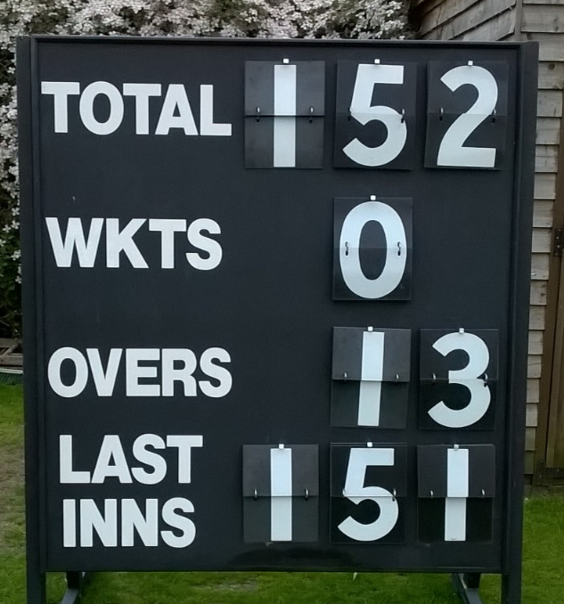
FDCC vs Remnants 17th May
Zilcho
Whilst, for the purposes of Saturday league cricket, FD players have found themselves ‘set by ability’, it was most pleasing to see a ‘mixed ability’ team comprising a few firsts, a few seconds and a junior assemble under grey skies at Fitz. We were also delighted to welcome Wayne Clements back into the FD fold for his first match since 2003 – we hope it’s the first of many more to come.
Having won the toss, Remnants decided to have a bat and lost one of their openers almost immediately to a pulled muscle (perhaps reaching for one of Gilo’s ‘swinging’ deliveries). At the other end, Wayne was reminding us all of just why he still tops the FD bowling stats, pegging the openers back with pacy deliveries. After 6 (8 ball) overs, Remnants had reached 37-1, with Wayne bowling their number 2. Darren and Mani took over and it was around this time that Samuel Serbey was starting to get his eye in, taking a particular liking to Mani’s deliveries. With similar ruthlessness, Mani was taken off after an over but might well have questioned the wisdom of this change as Jamie conceded two sixes off his first two balls.
Darren bowled well from the other end and almost clung on to a spectacular C and B. Jamie kept on tweaking and smiling and picked up a wicket in each of his two overs. Despite these, some decent ground fielding (excellent use of the shins Leo) and the three fielders on the leg-side boundary, runs kept flowing and Remnants were accumulating a decent total. Joe had by now joined the attack and had some success in staunching the runs whilst at the same time taking a couple of wickets, including Samuel Serbey for 68. A quick change behind the sticks allowed Marc to bowl the penultimate over and, thanks to some crisp hitting from Dave Norman, Remnants finished on 151.
With 10 an over required, Marc and H (“two decent club batsmen”) set about the chase briskly, with both of them producing an array of shots which prompted ‘oohs’ and ‘aahs’ from those watching on. Both showed the ability to nurdle when needed and hit out when the opportunity presented itself. As the score grew so did, I must admit, our surprise that Marc hadn’t yet got out and was playing with ever more assuredness. H hit no fewer than four 6s in his innings – one sailed high into the net on the pavilion boundary and another, a straight 6 over mid-off, prompted Dave Norman to ask whether H had been “working out”. Unusually for him Marc was less aerial but found the boundary rope on 11 occasions with a range of proper cricket shots.
Remnants changed bowlers regularly but, despite a few nicks and Chinese cuts (which really just served to complete a very impressive cartwheel for both bats) none of the Remnants bowlers were able to make the breakthrough. One unfortunate bowler saw his 8 balls go for 26 runs. And so it was that with (I think) 15 balls to spare, Marc (I think) claimed the winning single into the offside (I’m sure about that) to round off a super, super run chase. Marc ended on 64* and H on 73*. I’m not sure of FD partnership records but this has got to be up there. As they left the field to applause and much jubilation, Marc’s beaming smile and H’s sweat-matted hair bore testament to the fantastic achievement of scoring 152 for zilcho.
As they got changed, H mumbled something about “nobody doing a match report” and Marc was left to rue the fact that he didn’t actually run the sweepstake about how long he would stay in. After all, if Leicester won the prem at 5000-1, what odds would you have got on our Marc carrying his bat?
So a good night for FD in so many ways and a sign that our club is in rude health – let’s hope for another cracking game in the return fixture on 7th June – who’s in? Marc? H?

